To update the Service Mapping Power BI file, go to Power Query by clicking Home > Transform Data
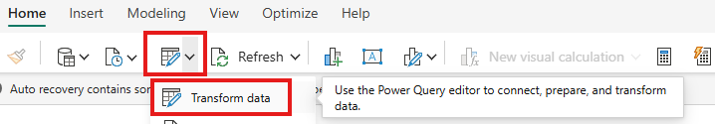
Then type in the file location over the top of the existing link:
